**Project Design Phase-II**

**Data Flow Diagram & User Stories**

|  |  |
| --- | --- |
| Date | 31 January 2025 |
| Team ID | PNT2022TMID45799 |
| Project Name | TrafficTelligence: Advanced Traffic Volume Estimation with Machine Learning |
| Maximum Marks | 4 Marks |

**Data Flow Diagrams:**

Here is the tailored content for your **TrafficTelligence: Advanced Traffic Volume Estimation with Machine** project under the **Project Design Phase-II** section. This includes both the **Data Flow Diagram (DFD)** and **User Stories**, fully aligned with your traffic prediction system:



**Example:** [**(Simplified)**](https://developer.ibm.com/patterns/visualize-unstructured-text/)

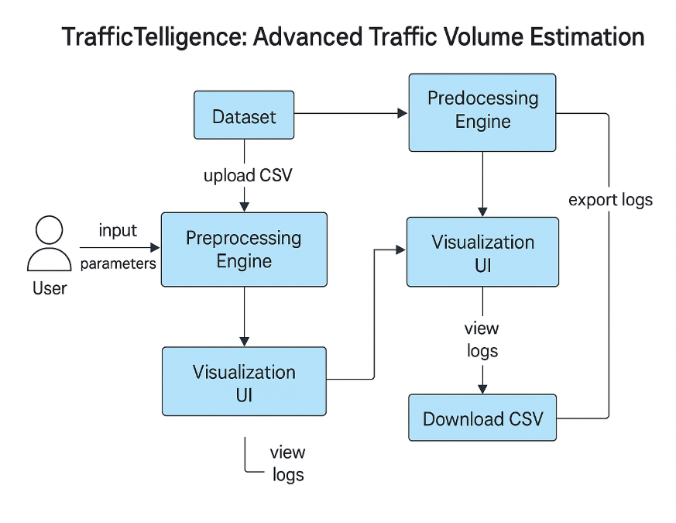

**User Stories**

Use the below template to list all the user stories for the product.

| **User Type** | **Functional Requirement (Epic)** | **User Story Number** | **User Story / Task** | **Acceptance criteria** | **Priority** | **Release** |
| --- | --- | --- | --- | --- | --- | --- |
| Customer (Mobile user) | Traffic Volume Prediction | USN-1 | As a user, I can enter weather and time data to get predicted traffic volume | Predicted volume is shown clearly after input submission | High | Sprint-1 |
|  | UI Interface | USN-2 | As a user, I can view predictions on a simple web interface | Output displayed with date/time and clear formatting | High | Sprint-1 |
|  | Prediction History | USN-3 | As a user, I can view the history of my past predictions | Table or chart of logs shown with previous inputs and outputs | Medium | Sprint-2 |
| City Traffic Analyst | Report Generation | USN-4 | As a traffic analyst, I can download prediction logs for analysis | Log file available for download in CSV/JSON format | Medium | Sprint-3 |
| Admin | Manage Logs | USN-5 | As an admin, I can clear or archive old prediction logs | Logs can be purged or archived with one click | Low | Sprint-4 |
| Developer (Admin) | Model Update | USN-6 | As a developer, I can upload a new trained model to improve prediction accuracy | New model replaces old one and begins serving predictions | Medium | Sprint-4 |
| Developer (Admin) | API Access | USN-7 | As a developer, I can test API endpoints for input/output automation | API returns valid predictions in JSON format | Medium | Sprint-2 |